White Feet On Another Land
In 1949, Harry Brorby described himself as having two selves, both being very different. One self is the soul Harry projected socially to the world, the other is the soul of his loves: painting, drumming, and creative outlets in general. It is the soul he thought he could not truly share with the world—except in his art. I wish to address the personification of this second self, in his art and in his poetry, using outside sources to back evidence found in support of this second self, and to determine to what extent Brorby inner self has materialized in the real world. This inner soul, however, is inherently dark. In his paintings, prints, and poems, he explores themes such as loneliness, disparity, darkness, depression, and emotional pain. These themes are overarching of his entire career; they are explored early in 1949 in a twenty-three page long collaboration of poems titled “Intermission,” and stuck with him to his death—his home being filled with death icons from different cultures.
Harry Brorby was seemingly obsessed with the idea of death. His home in Holland, Michigan, was filled with odd totems and artifacts from different South and Central American cultures. His living room was filled with artifacts such as death carts, Santos figures, old bloody crucifixes, tapestries, and the like. The blinds were closed, and the area containing these artifacts was often as dark as the artifacts themselves. Friends of his son, Mike Brorby, were often terrified of spending time in the house (Bennick, 2015). Even though he collected religious artifacts, he himself was not very religious (Bennick, 2015). It seems as if he was interested in these artifacts not for their religious value, but for their connection to death. Many of his works, such as The Crucifixion and Dead Trees reflect this idea.
Beyond death, he expressed interest in loneliness. It is unclear whether he enjoyed loneliness, or if it tortured him. He was said to be a solitary man by his friends, which could lead one to believe that he enjoyed time alone (Bennick, 2015). And in one of his poems, “I Am Obsessed With Grapenuts,” there seems to be confusion as well he writes,
it is necessary
to search for
alone.
Yet later, he thinks about what he is saying, and decides he has it wrong.
but,
why did I say
it was necessary to search for ALONE AND GREY?
So it does seem as if there was confusion between whether or not solitude was welcomed, but the conclusion Brorby seems to have come to is that solitude is not a choice. He writes of being misunderstood, in a place of forced solitude—a place he does not belong. In his opening series of his set of poems, titled “Intermission,” (he also named the work as a whole Intermission) he wrote,
black footsteps on white sand,
white feet on another land.
It seems to be clear that he is experiencing feelings of loneliness. The opening trilogy to Intermission is entirely about his loneliness, in which he expressed deep emotional concern about his state of affairs at the time. In 1949, Brorby was in his final year at Harvard. One could expect a freshman or sophomore to feel lonely in college, as it is a time of great change, but a senior? He must have felt removed from society the entire time he was there, suggesting that he did not enjoy solitude, that it was indeed torture. The entire trilogy is about suffering. He starts with comparing the sun with an electric lightbulb. He is calling the sun artificial, a thing of fleeting permanence. He also seems stuck in the mire of his memories, swirling around in a nostalgic whirlpool that he cannot swim out of. It is because Harry is trapped in his memories that he cannot connect with the world around him. It is because Harry is trapped that he compares himself to his shadow—a silhouette of himself. His shadow and he are “united in blue,” and because his shadow is always a part of him, he seems to suggest that sadness is too. He states that he tries not to think about it, saying that “thinking is in black,” the color of death, depression. Brorby as a whole is shrouded in darkness. His true inner self is that of lamentation. He felt as if he did not belong in the world he lived, and therefore created his objective self as a shield from it.
Apart from emotional dredges that separate Brorby from a society socially based upon happiness, there is the idea that he does not fully understand others. He writes three poems in particular which can lead one to believe this. The first can be considered an insight into himself. It seems as if Harry is criticizing himself for acting falsely in creating his objective self. The title says much in itself: “Sacred Somnambulations.” To somnambulate is to walk during sleep--a sacred somnambulation must be an act reverently dedicated in sleep. Brorby uses this term as a description of his objective self. It is a personality that he acts out diligently, yet it is as if he has a veil pulled over him. In the first half of the poem, Brorby describes a situation in which he would be showing empathy towards another, and in the second half, he describes serpents as laughing at him. They laugh at him because they know the truth: Brorby’s empathy is a somnambulation. To give a historical context which would bolster this theory: Jiri Kolaja and Robert N. Wilson write about their classifications of poems written in the middle of the twentieth century—the same time Brorby was writing. They argue that, “Although the verse is well-peopled, the individuals do not act upon one another; rather, they are analyzed in a kind of sociological vacuum,” (Kolaja, 1954). The poem does seem to be addressing Brorby and at least one other person, and yet it does not exactly describe Harry as acting on this other person. Harry has, then, created this sociological vacuum in which to judge himself in. Yet, in loosely following this common poetic construct of the mid twentieth century, Brorby simultaneously writes on a more thematically unique feature: the social-relatedness of human beings. According to Kolaja and Wilson, “social-relatedness of human beings is not a prominent feature of the poetic landscape” of the mid twentieth century (Kolaja, 1954). This theme appears in Harry’s works often. It is his mixing of proper discourse in a social situation with the relatability of himself in one poem that helps him create an extremely cerebral piece of literature—leaving a very flexible foundation on which to build the theory describing Brorby’s objective and subjective self.
The next poem, aptly named, is “Sleep-walking.” This poem seems to be a commentary on religion. The poem ties closely with “Sacred Somnambulations,” and is Brorby’s way of stating his confusion about religion and why others get involved. “Senseless meandering,” Brorby calls it. The poem voices Brorby’s feelings about religious people, calling them fools over and over again. He has no understanding of the average person’s “sacred somnambulations.”
This poem seems to come to life in visual form in Brorby’s The Crucifixion (Fig. 1). In this work, Brorby depicts a central figure, one with multiple roles. This figure appears to have multiple arms, which are used in enacting its multiple roles. The first is that of the maestro. The figure is set in a position of conducting an orchestra, and by the body language of the figure, the piece being played seems to be somber. Good music manipulates the emotions of the listener, and one could believe that Brorby uses the maestro to depict such a manipulation. A manipulation related to the figures other role: Christ crucified. Behind the maestro, arms jut out into positions which would be held on the cross. A massive nail spikes into the scene onto the left arm of the figure, assuring the viewer that the figure is indeed Christ. Once could believe that connection Brorby makes between Christ and the maestro are fitting to his personal views on religion, expressed in his poem “Sleep Walking.”
sacred somnambulations
senseless
meandering
aimed at saint
strengthened by misconception.
Here Brorby describes what he must observe of the religious society he sees around him. “Senseless meandering” is what he calls the actions of those following religion—those depicted behind the maestro/Christ figure in the etching. There are a handful of figures in the background, all of which portraying an action Brorby might find distasteful in the name of religion. The first of which that one’s attention goes to is the figure wearing a look of awe upon his face—which is caressed by the hand of the maestro/Christ figure. One could say that this character is expressed verbally in the first two stanzas of “Sleep Walking” (Brorby, 1949). He is the senseless meanderer, the fool searching for freedom. Brorby hints at this with the facial expression of this character, and the character’s outstretched arms toward the maestro/Christ figure. It seems as if he is ready to fully devote himself the central figure. He is so fully enraptured by the song of the maestro/Christ figure that he is ready to senselessly follow him, ready to throw out the state of thinking that Brorby places with high esteem, as implied by his scathing attitude towards such followers as this character.
The next character that will be brought to the attention of the viewer is the faceless character standing slightly behind the senseless meanderer. This character appears to be wielding a sword, raising it in what looks like praise to the maestro/Christ-figure. One could believe that this is Brorby’s commentary on those who fight in the name of religion. The figure is faceless, suggesting that he represents many people. By putting this character in the same group as the senseless one, Brorby casts him in a negative light. He seems to be expressing disdain for those who commit violence in the name of religion. This idea leads to the understanding of the next character, the man behind all others, donning what seems to be Klansmen’s robes. His position next to the sword and looking towards the maestro/Christ figure states the importance of violence and religion to his cause, another which Brorby seems to find to be deplorable. Possibly deplorable in their acts, and also in their justification with religion. “Freakish sanctity for those who misinterpret” seems to mesh well with the Klansman and Brorby’s personal view of that group, a group which would have been highly active at the time the poem and the etching were made, between 1949 and 1954. These characters all describe a certain aspect of the problems Brorby wishes to address about the followers of the church. Considering Chris Overvoorde’s description of Brorby—a kind hearted and gentle man—the connections made between The Crucifixion and “Sleep Walking” seem to strongly personify Brorby’s subjective self (Overvoorde, 2015).
The final poem gives the reader a deep view into Brorby’s objective self. Titled “Disinterest,” it is a poem in which Brorby explains his perplex thoughts behind human social interaction. He does so in an interestingly demeaning way, by likening people to monkeys. He writes about how easily a monkey learns movements, and how quickly it would learn to go through the motions in order to receive the reward. He sees this laboratory inspired operation in society, and knows that it goes no deeper than the surface. This upsets him, and he emphasizes every word in the last idea in his poem: “all of this was simple for monkey to understand, but, HE will never understand monkey.” Another idea one could conjure from this poem is that Brorby refers to himself instead of society. The beginning half of the poem describes how easy it is for him to learn societal norms within conversation. He learns it so well that he can play it off effortlessly. Handling conversation with such finesse would augment his objective self, making the subjective harder to spot in any place other than his art and writing. Yet, even with such a grasp on the art of conversation, Brorby seemingly cannot deeply understand the emotions of another person. The latter theory goes hand in hand with the theory behind the poem “Sacred Somnambulations.”
Harry Brorby seems to be heavily fixated on his interactions with those around him in 1949, and this fixation is not lost in later years. Even more so, Harry stays constant with his connection to ambiguity, seen both in his poems—of which I have discussed, among others—and in his Yellow Series (example fig. 2). For context, the Yellow Series was painted by Harry in the late 1960s and early 1970s. It is a series in which Harry is fixated on the construction of corners, and the motion of line. This series carries with it a large amount of ambiguity, as most of the paintings focus on close ups of corners, leaving the rest of the shape out. These Rothko-esque paintings seem to be based off of a much smaller, more complete set of paintings found in the Harry Brorby Collection at Hope College (Brorby, N.D.) Every Yellow painting seems to be the child of a focus point on one of these smaller paintings (the small paintings are all the same). The finished Yellow Painting would encompass these three ideas: ambiguity, obsession (fixation), and mystery.
Ambiguity: an idea played with in Harry’s poems, and further considered in his Yellow Paintings. For a more specific example of poetry, one could look towards the poem Pink-Yellow. This poem is written only in colors. What idea is he trying to convey? It seems as if he is trying to take the reader on a mental ride through a series of colors. One could only imagine what they mean, but it may be a safe assumption to say that he wants the reader to feel a certain emotion. What emotion, one does not know. This poem is packed with the ambiguity that shadows Brorby’s writings and his paintings.
Brorby’s ambiguous Yellow Series reflects a very similar minimalist style as Frank Stella. Stella’s Black Painting (example figure 3) has been described as “stripped of all thematic or emotional content,” a phrase that could also describe the minimalist Yellow Series. Yet, it is more than that. Brorby is able to portray his work in a fashion that would seem devoid of emotional content, yet there is an inexplicable mysterious feeling derived while viewing this series—a feeling very similar to the emotions conjured while reading his poetry. This ambiguity seems to rise from Brorby’s fixation.
It would almost seem stereotypical to call Brorby, the artist, obsessed. Even so, he clearly exhibits this trait. It is evident in his creation of the Yellow Series. He painted a massive amount of these, all very similar to one another. He kept his collection in racks located within his Pease Dome studio. Once, his radiator exploded in the Pease Dome, covering all of the yellow paintings with soot. He paid to have every single one cleaned, showing that the obsession is evident even without delving into the subject matter of the paintings. In the paintings, his obsession becomes undeniable. Every painting is massive, and all very similar. Brorby painted the same thing over and over again, with minor variations. It is this obsession with his work that births ambiguity. Every painting is a piece of the whole, the idea, and when viewed apart, the sense of mystery again surfaces.
This sense of mystery encompasses Brorby and his subjective self. It may become evident that, as an artist, Brorby tried to reflect his subjective self, and in many cases succeeded. But he has also created a shroud of mystery in which he covers himself. Brorby will remain a source of intrigue to his audience, because of the unknown. It is the fact that his subjective self is seen only through the misty haze of ambiguity that he remains, and captures an audience. He supplies the audience with ample evidence of his subjective self, and hopefully, one may catch a glimpse through the fog of the real Harry.

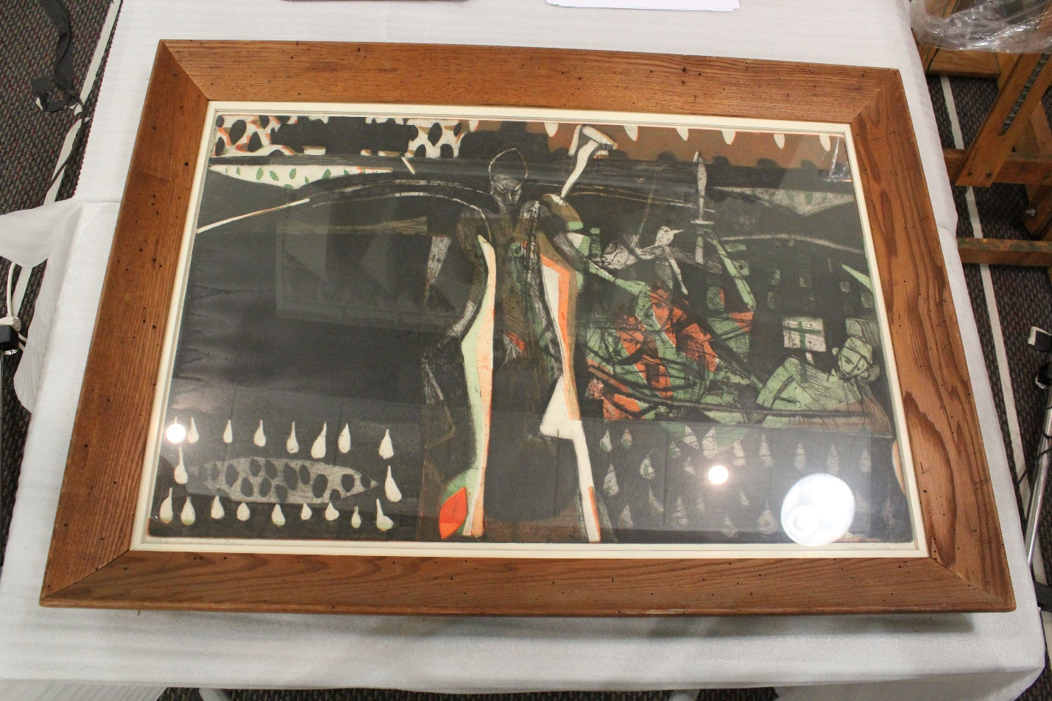
Figure 1.
The Crucifixion, by Harry Brorby, undated.

Figure 2.
Yellow Series #4, by Harry Brorby, undated.

Figure 3.
The Marriage of Reason and Squalor, II, by Frank Stella, 1959.

